Retail Mart Management

1. Write a query to create a database named SQL basics.

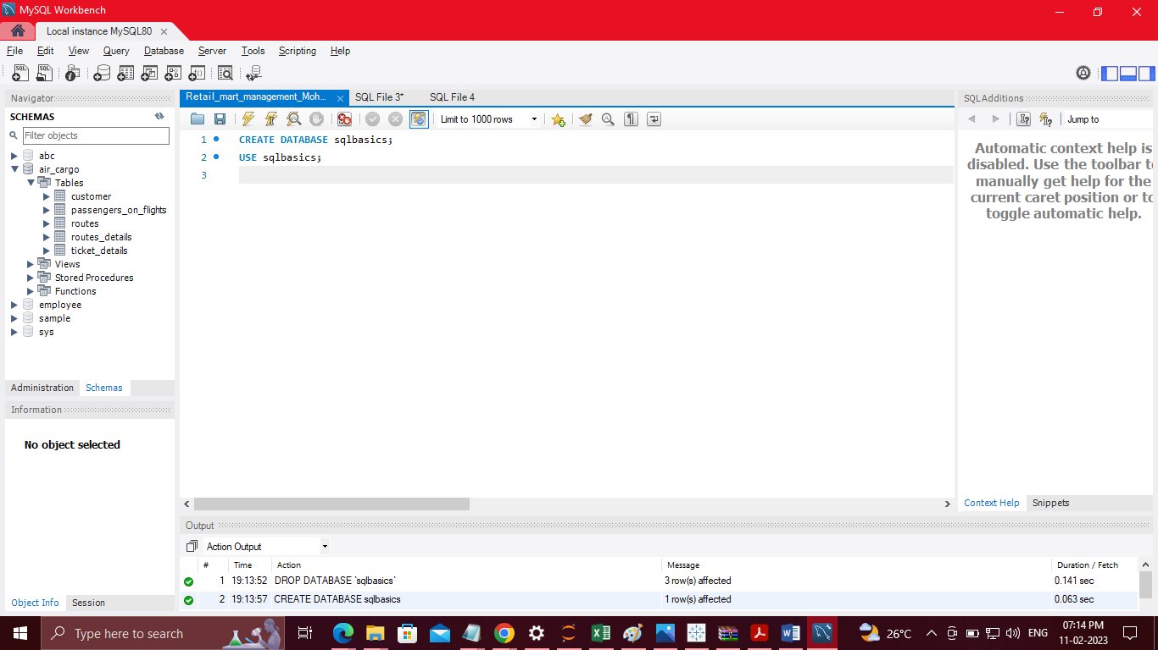

2, Write a query to select SQL basics



3, Write a query to create a product table with the fields product code, product name, price, stock, and category, a customer table with the fields customer ID, customer name, customer location, and customer phone number, and a sales table with the fields date, order number, product code, product name, quantity, and price

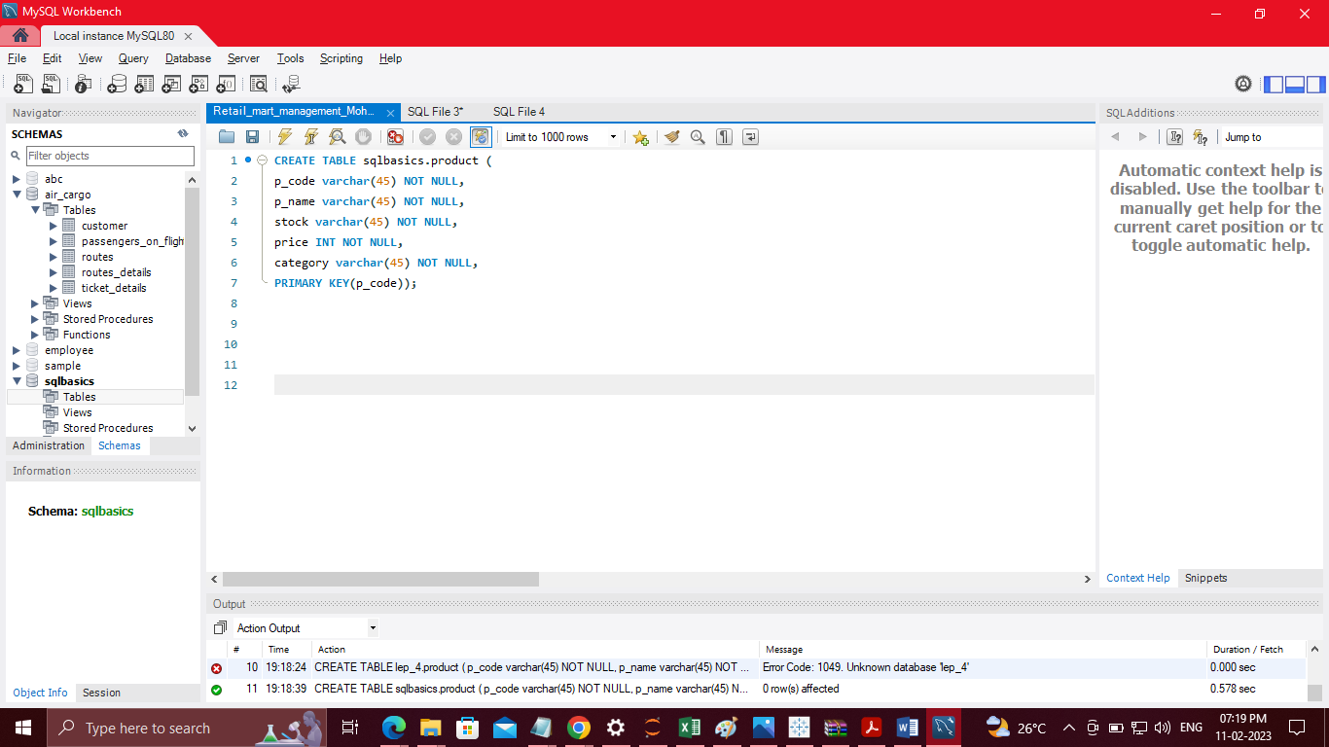

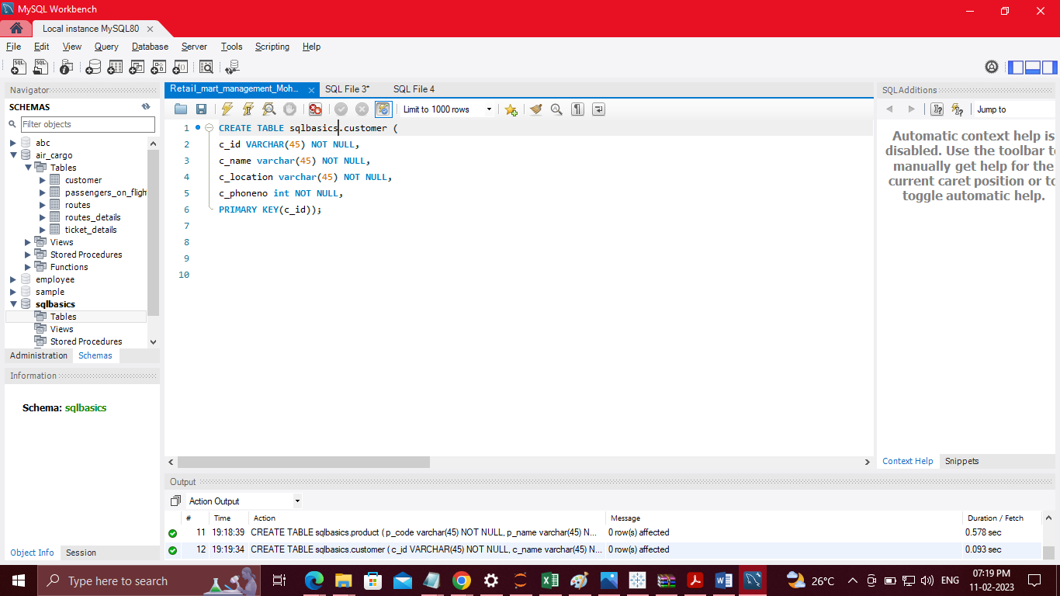

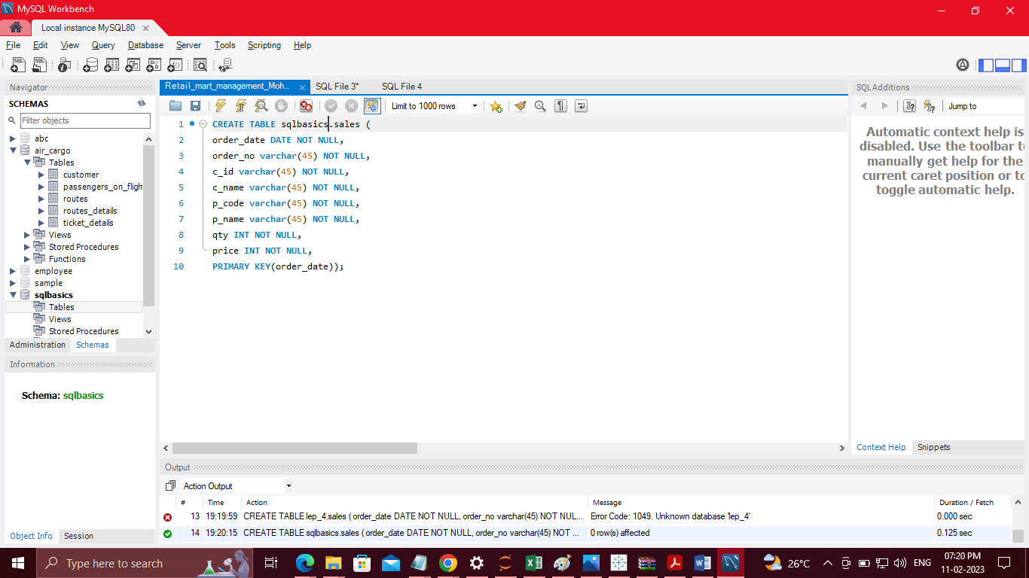

4, Write a query to insert values into the customer, product, and sales tables

Insert values into customer table

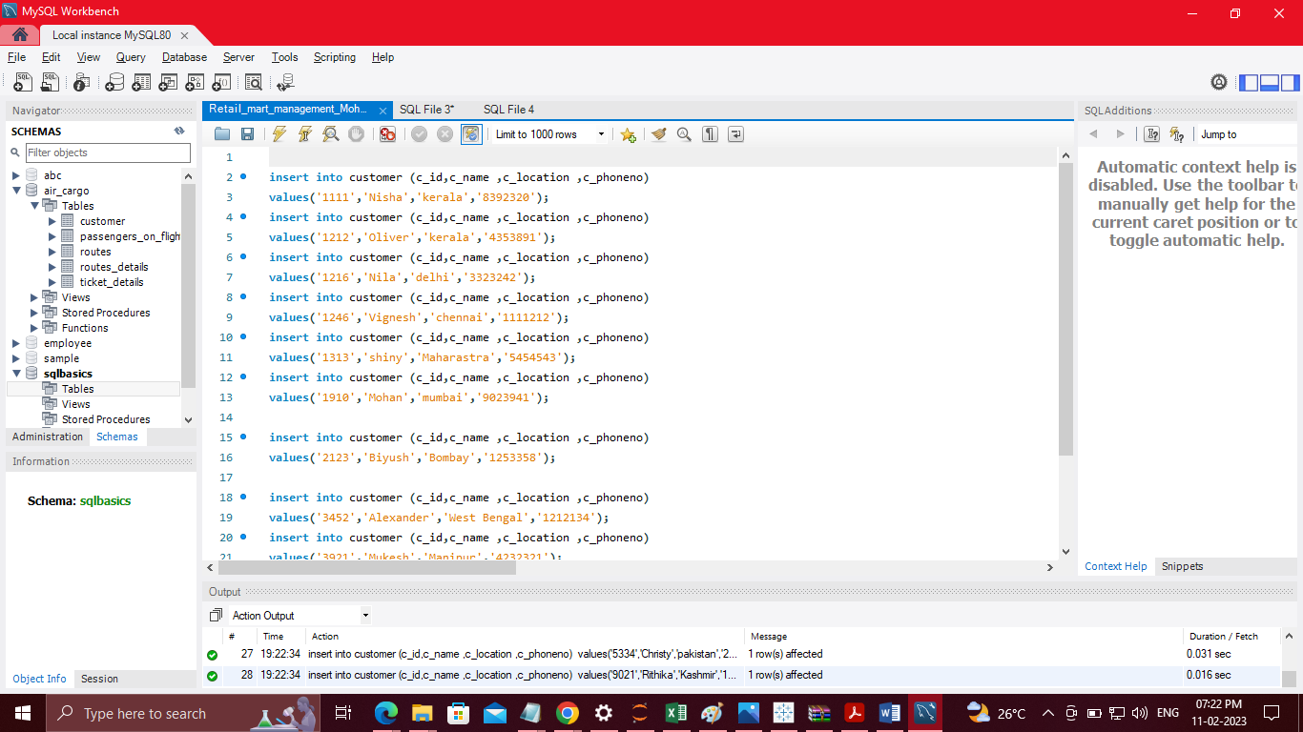

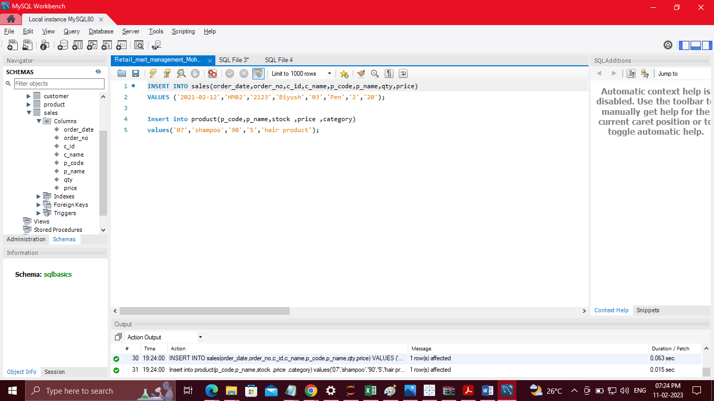

5, Write a query to add new columns, such as serial number and categories, to the sales table

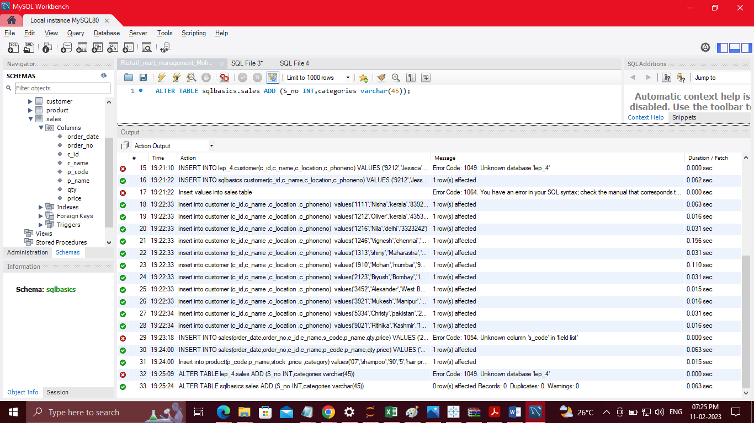

6, Write a query to change the stock field type to varchar in the product table

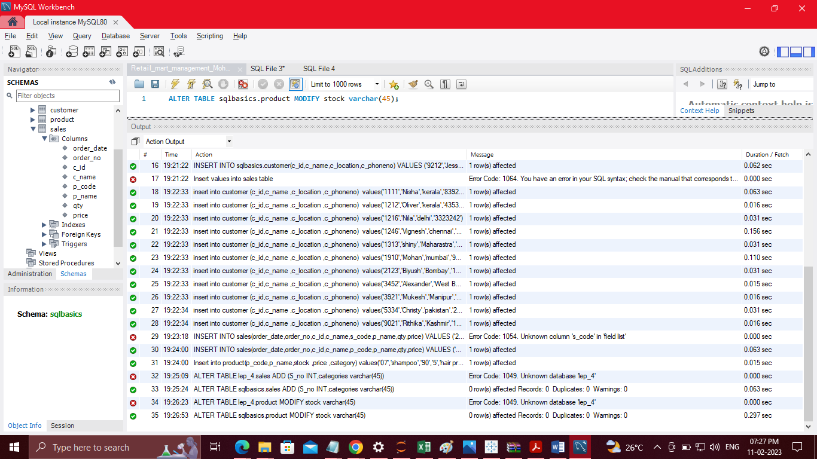

7, Write a query to change the table name from customer to customer details

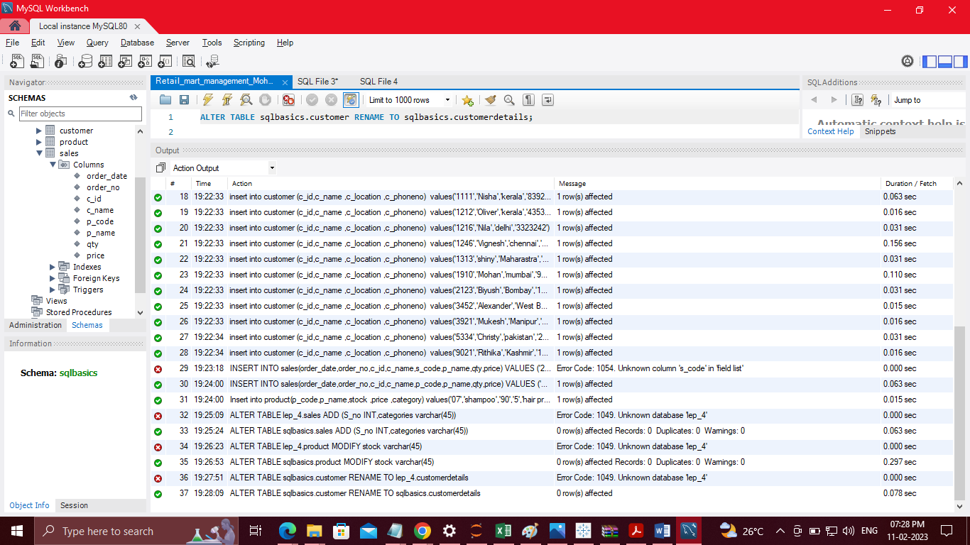

8, Write a query to drop the sl. no. and categories columns from the sales table

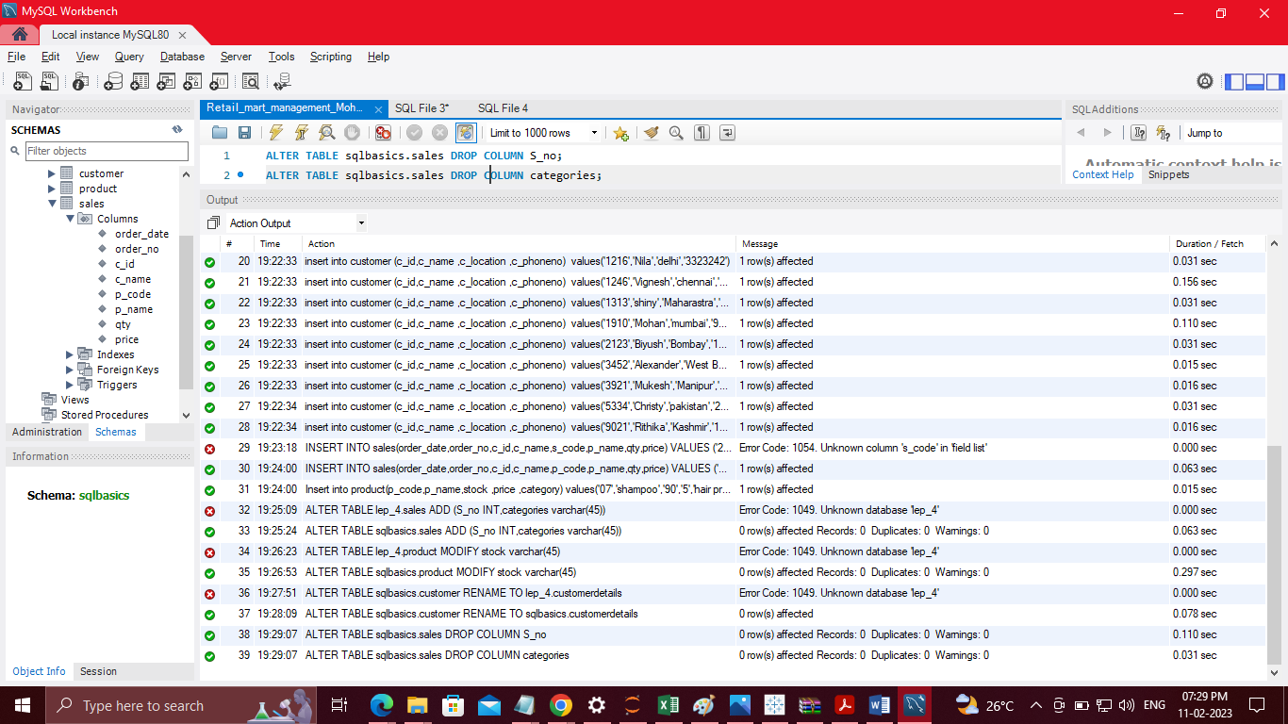

9, Write a query to display the details where the category is stationary from the product table

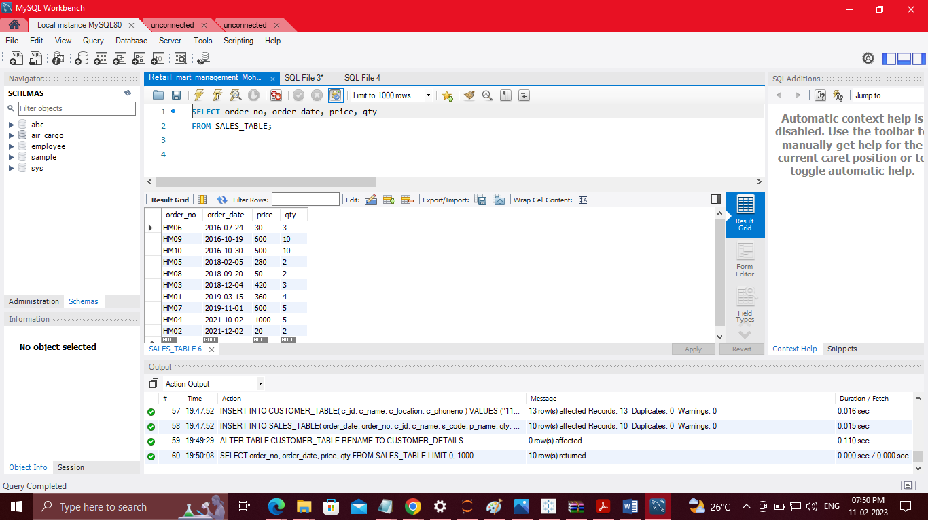

10, Write a query to display the details where the category is stationary from the product table

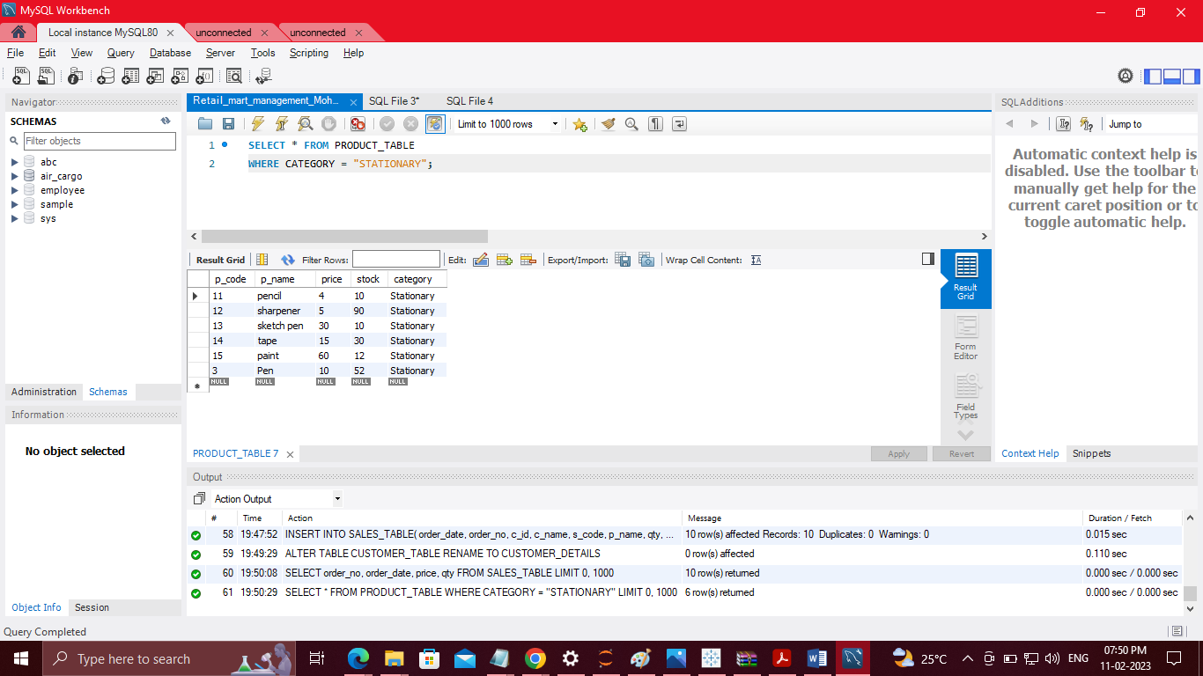

11, Write a query to display the unique category from the product table

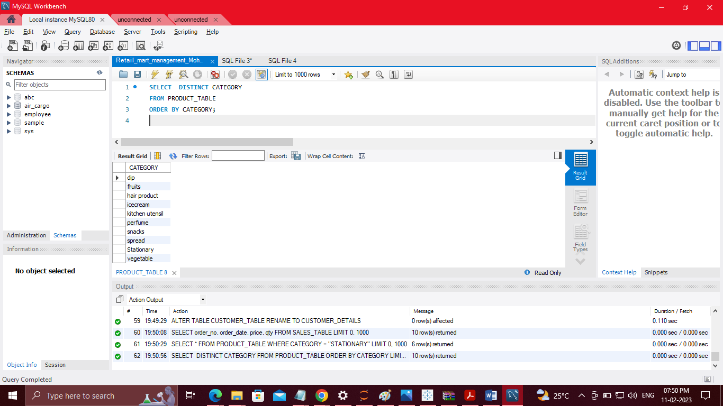

12, Write a query to display the details of the sales from the sales table where quantity is greater than 2 and the price is less than 500

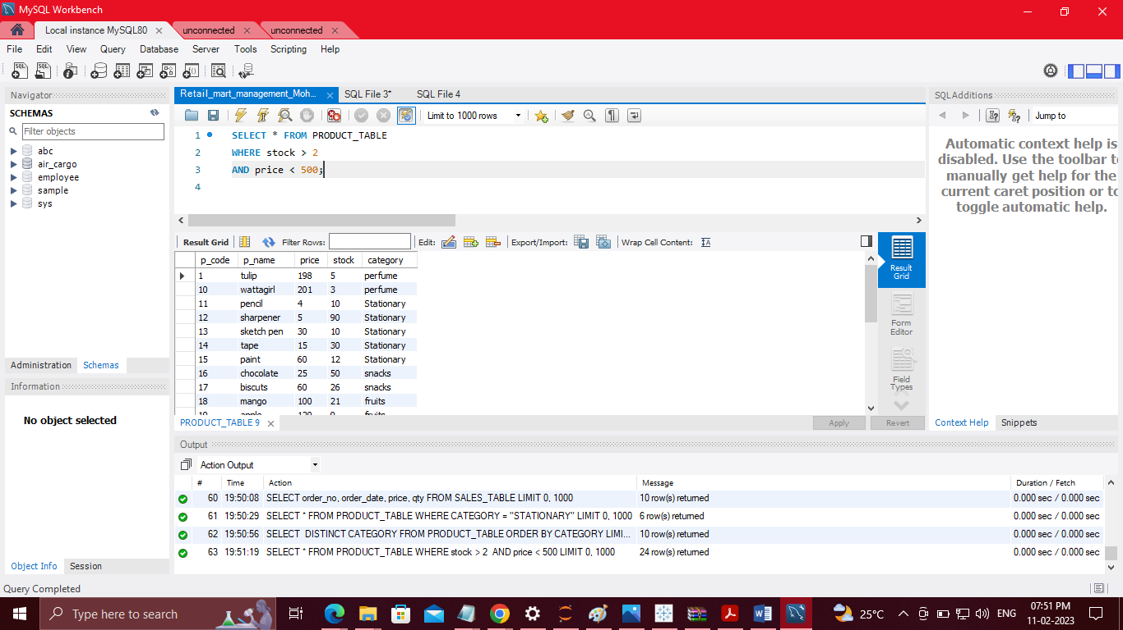

13, Write a query to display every customer whose name ends with an 'a'

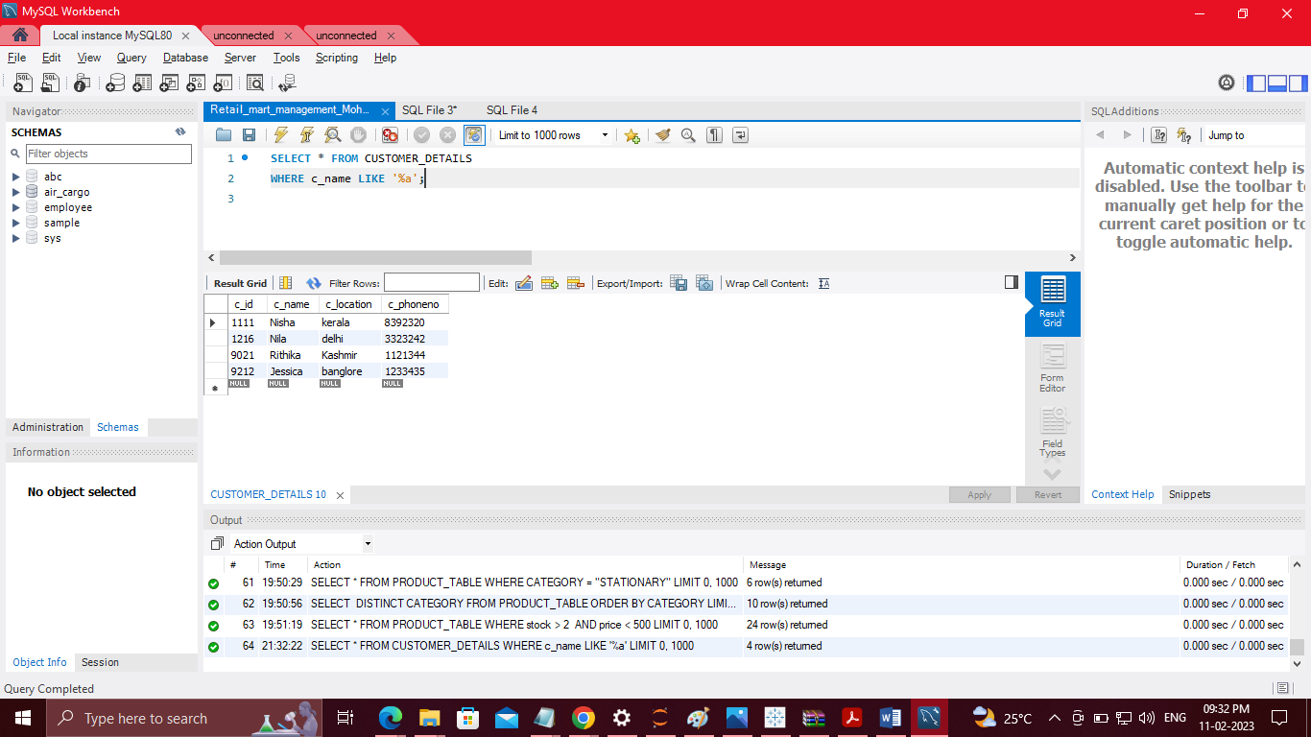

14, Write a query to display the product details in descending order of price.

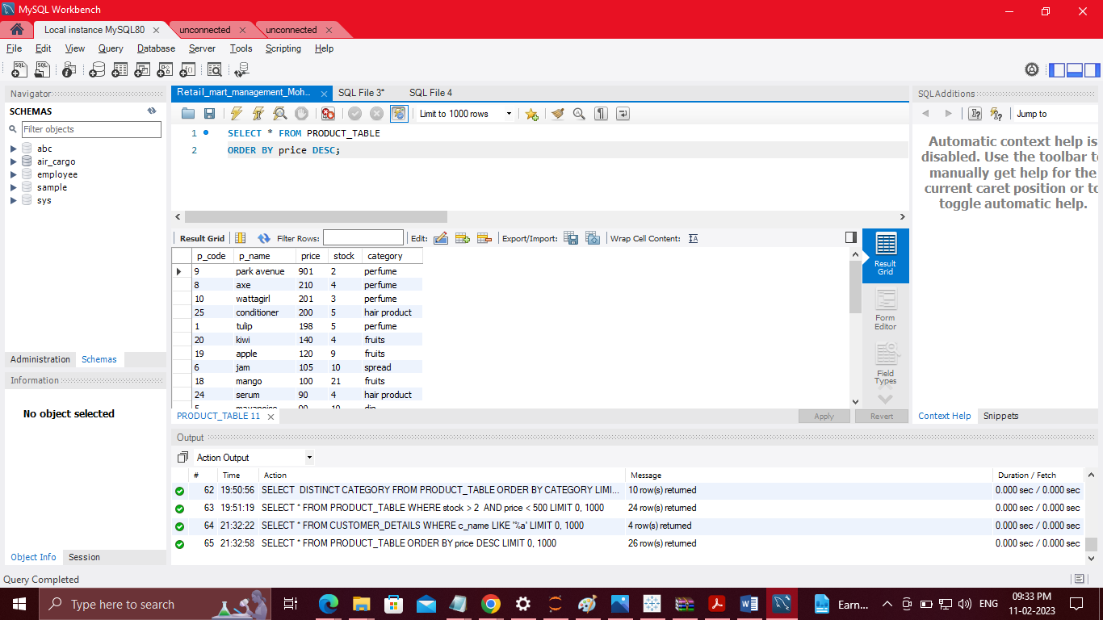

15, Write a query to display the product code and category from categories that have two or more products.



16, Write a query to combine the sales and product tables based on the order number and customer's name including duplicated rows

